POPULAR PRODUCT

Part Number | Model | Lamp | Description | Dimensions inch (mm)
 |  |  |  | Total Height (H2) | Illuminated (C) | Non-illuminated (A & B) | Base Height (H1)
R7P14ESUS | RL70EP-114X | T5 | 1X14W, 120-277V, 50/60 Hz | 57.4” (1458) | 21” (533) | 4.9” (125) | 26.5” (673) | 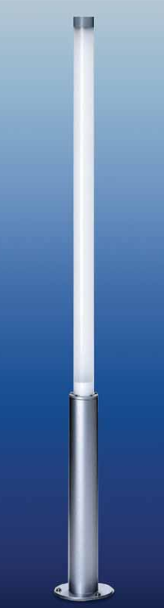
R7P17ESUS | RL70EP-117X | T8 | 1X17W, 120-277V, 50/60 Hz
R7P24ESUS | RL70EP-124X | T5HO | 1X24W, 120-277V, 50/60 Hz
R7P2LESUS | 2 FT. LED | LED | 1X10W, 120-277V, 50/60 Hz
R7P21ESUS | RL70EP-121X | T5 | 1X21W, 120-277V, 50/60 Hz | 69.0” (1753) | 32.5” (826) | 4.9” (125) | 26.5” (673)
R7P25ESUS | RL70EP-125X | T8 | 1X25W, 120-277V, 50/60 Hz
R7P39ESUS | RL70EP-139X | T5HO | 1X39W, 120-277V, 50/60 Hz
R7P3LESUS | 3 FT. LED | LED | 1X15W, 120-277V, 50/60 Hz
R7P28ESUS | RL70EP-128X | T5 | 1X28W, 120-277V, 50/60 Hz | 80.9” (2055) | 44.5” (1130) | 4.9” (125) | 26.5” (673)
R7P32ESUS | RL70EP-132X | T8 | 1X32W, 120-277V, 50/60 Hz
R7P54ESUS | RL70EP-154X | T5HO | 1X54W, 120-277V, 50/60 Hz
R7P4LESUS | 4 FT. LED | LED | 1X17W, 120-277V, 50/60 Hz

Features:
- LED lamping
- IP67 waterproof protection
- 3000K, 3500K, or 4000K available (4000K is installed standard)

See next page for dimensions.

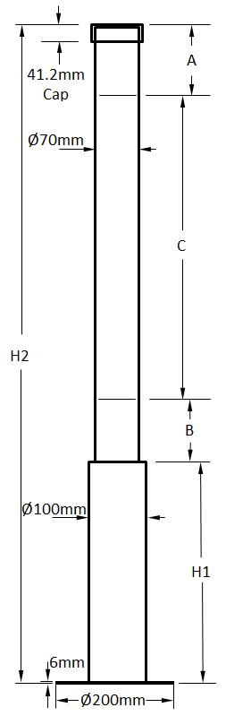

Mounting Base
