D11'e.a vivaa

Installation and operating instructions

0400/ 600

0160

'I I

0 112

w A

VARIANTS

SAFETY

|  |  |
| --- | --- |
| fZJ: | 400 / GOOmm |
| UingeI LenghtI LongueurI Lunghezza: | 1501500mm |
| Bel nde Clear cover *I* CacheI Diffusore: | COP  oder *I* or *I* ou *I* oppure  Acryl weiss satinienI Acrylwhite satinedI Acrylique blanche satiner *I* Acrilico bianco satinato |
| Versionen*I* Versions *I* Versione: | DALII SENS I VTL |

Read aU inchJded inltrtKt•onsend intormet.an. The device must be used m tedu"M c.lly perfect condJhon, end only by s.efety-c:onsaou• parsons who are fully ewere of the rish The lummalfa must only be operated 1n dry, du5t.frM rooma.for lumineitH 1n protection dass t, it11enen11al tor the ..nhing eondumr to be connected to the lumineire housing The manufacturer cannot be h.,d r.sponsible for an lnJUfY or damage that is c.uMd •• a result of any uH other than the intended use or of any failure to comy wi1h the safety inttrucriont and warning' Thelumineire is authonzed for uu in medil a reulunde r EN-60598·2·25).h it not Intended for use in operating theatres. Do not useln expJoal ve and ha.zardous atmo1pher11. Check·The maint voltage with the nominal voltage and the frequency muat match th e data on the name plate. Before starting work disconnect the lumma1re from ma ins. All mamtenanc.e and repans must be done by qual1fitd pen:onnel tra1ned and au th orited by the manufacturer. Mounting must be done by qualified per.onnel only. The use of unsuitable tpare parts could retult in an injury end property damage. Uu of sp a re partt: to be releated by the manufacturer only. The luminaire itself it maintenance·free. In eau of an outf1ll of the LEO module, contact t he manufacturer sarvice

ASSEMBLY

Befestigungli>matt rlalltt nicht im Lieferumfang enthalten , Verwenden Sie nur Befestigungsmaterial , welch..fUr den entsprechenden Untargrund geeignet iat Tragen Sle Handschuhe, um FingarabdrUcke zu vermaiden. Mounting material is not induded. Use onty mounting material which is suitable for the corresponding tubstrete. Please wear gk»vet to avoid f1ngerprintt.

le systima de fixation n'..t pel fourni.UtiliMr uniquement le.ystetne de fiXation adapti au auppon CIOtr..pondent. PortN des gants pour •vitar tout trande doigta. "mal'enale di fi1uogio non ••n dotazione. UtihuaNaoflanto material• di fiuagg.o adatto at aonofondo lndouere guan1i per *.-A*tare d1 lasclere impronte

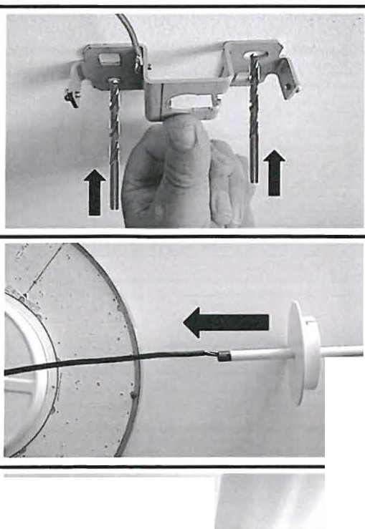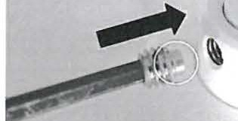

2

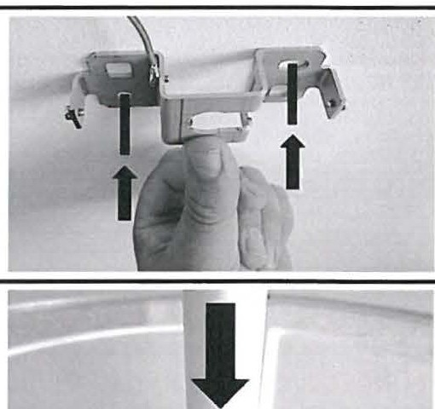

3 4

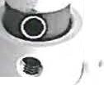

5 6

*)*



7 8

3Nm

9 10

11

|  |  |
| --- | --- |
| N | blue |
| PE | green-yellow |
| L | brown |
| DALI | black |
| DALI | grey |

Power connection

13

TECHNICAL DATA

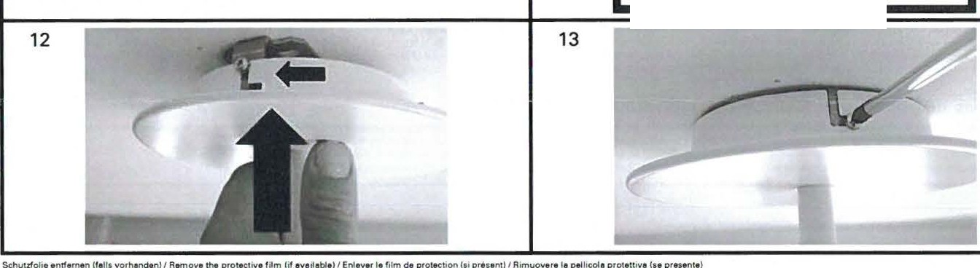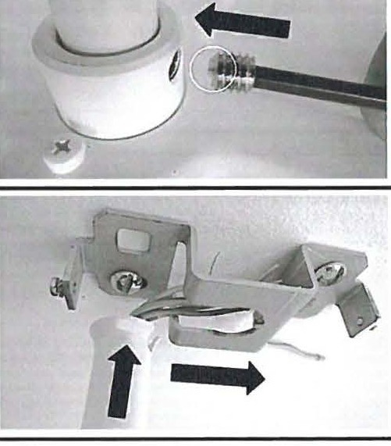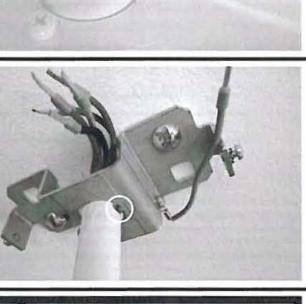

|  |  |  |  |  |  |  |
| --- | --- | --- | --- | --- | --- | --- |
|  | | 220-240V | | | | |
| Fr yenzb.re•ch *I* Fr u.ncy rnge / Plege d•tr enc.!Gemma d1 fr Quenu | | S0/60Hz | | | | |
|  | | 0400mm*I* OAU *I* Sf.NS j_ 0400mm *I* VTL | 0!00mm *I* OAU *I* SENS 0600mm / | | | VTl |
| 54W {55VA) 64W 16SVAJ  *0* 24A 0 28A | 82W83VA) 99W l101VA)  036A 0 44A  O&oomm | | | |
| 4 3ko ll b•l | • lkg tt711bsl | |  | |
| •lO'"C ·lO c | | | | |
| rei Luftfeuchta (rweht \ondt,.rend) CS.tr )/ Rele1NI hum1drty lnona nt.ng)(opera bon) /  Hum1dltt ,.. . de r u (aant concMt\MtiOft) {foncttonnemant)*I* UmKhtire4Miva de'l ar.a (prrvod1c | onde,..) Uunnonamentol | mu 15% | | | | |
| lebensdeuer LED *I* ServiCe ltfe LED / DY r•• de Y de le LfD/ Du rete dei lED | | 0400rnm SO'OOOh ll8018101 0CIOOmm. | | s& | 'OOOh IL801810) | |

DISPOSAL

-

Do not d ispose the lunune•r• I n housahokt refuse Dtspoaa the lumtJMif l to • d•spoul potnc 1n accordence with local regulebons or tah them to a dealer that prov1dn en appropr..ta dtspos• l serv1ce Cut off the cebla dtrecdy on the houang The products ltatad above era mora t han 85% reeydabla Tht lum•na .ras he"Va bMn «>natructad to bt compat•bt• wnh r• "Vchng ao tha t • htgh propon•on of tha m etene!s used in theM produ• cen be recycled or conv.rtad 1n1o anergy .ttar tha and of serv.ca hfa Th.-, con tain no mata nela thet ere dangerous or 11'11nHd to be monrtorlld

D.runve Ucht AO Holmettau•u• 12

CH-8200 Gosuu SG

( E

' Swrttartand

TeleQhone..171388116CI

Fax *n*

+<l 71 38111

www d..-ung•l•chleom

*r--r-,*Hetb.nW.tdmann GmbH a Co. teo

I I I

Posffaeh 60«12

C R EP 78057 Vlfl •ngen·Sehwennmgen

Germeny

Telephone ..u *n20* 601 o



Fax . a *7710* &01 210

www weldmenn com

D tsa Monte1.ifld Gabra uc. .nwetsung d1ant ausachhanlteh dar Kundan.nformauon und Wlrd nur auf Ku nfordeNf'IQ a ha!l rt odll' auagata U$Cht. Thua mstallauon and operaung instruct tOni are for cu11omer mformet10n onfy and w..l only be updated or replaca upon r.q uest by the cuatomer Cet matrucliOns d'1nstellat10n at da fonctlonnamentaont duhMet eu chent un•quamantet na laton!mtsas a,ou, ou remplec .t un1quama nt tur <Mmanda du chant le pratant1 tstfUl:tont pat '' monteggJO • I'Yao MNono asc:lutivam antt coma mforma.ziOI"'e peril d•anta • aono agg•ornete o tOitiiUita o t u riehteste del diante



OO.rungt LM::ht AG •OIO.OSO.OOOP 08.20t 4•1ndall \ *0*